Recommended Glam Artists Dubai
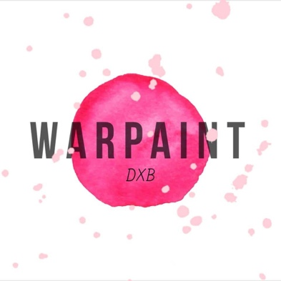
Warpaint DXB
Name: Sam Vince
Background: From the UK, been in the UAE for 9 years
Professional Background: A lifetime of makeup since I can remember but professionally for 3 years in Dubai. Freelance MUA who also works to support Award Winning British Salon - Locks By Lou Lou Hair Boutique
Preferred Style: Evening Glam!
Any other fun facts about you: A lover of all animals big and small. Would love to open an animal sanctuary - alongside doing makeup, of course!
Availability: Weekends and weekday evenings (larger groups on other days/times with prior booking)
Masterclasses offered: Yes.
Rough price guide: 350-550aed
Contact details: 0559501771
Glam N Go
Name: Beta Golchin
Background: I’m Persian by culture but I was born and raised in Dubai
Professional Background: I have been doing makeup since I was 14. But professionally I’ve been doing it for 7 years now. I am Sephora Certified and worked there for 2 years followed by a year at Dior. I have all types of clients from new brides and their bridal party, New mom to be for their baby showers, girls going to prom, Beauty Pageant (Mrs Maryland and Ms Veterans in the US) to private photoshoots, fashion shows, print editorials, corporate commercials and movie production, Halloween Gore Special Effects Makeup.
Preferred Style: I prefer a natural glam and if I wanted to go full on glam I love to focus mainly in vamping up the eyes but keeping everything on the face soft and natural looking
Any other fun facts about you: I won a junior Art Competition in high school that I was taking place in Japan and won a bronze medal. I was 13 years old and the picture I drew was of a woman’s face with makeup using color pastels.
I love interior design and cooking and always like to experiment with ingredients.
Availability: I’m available within 1 day notice period as I am freelancing with InstaGlam and may be starting some freelance work with a film production company soon as well.
Masterclasses offered :Yes I am currently offering 4 different packages with more information here https://www.betagolchin.com/course-description
Rough price guide:
My prices are here https://www.betagolchin.com/pricing
Contact details:
Email is glamngobybeta@gmail.com Website is www.betagolchin.com www.instagram.com/glamngobybeta
www.facebook.com/glamngobybeta
Mobile number is 0543731333

Deepika Rajani
Name: Deepika Rajani
Background: British Asian from London. Been in Dubai since September 2018 and for a few years before that.
Professional Background: Trained in the UK for all types of makeup including T.V and film about 15 years ago at where is now known as The Iver Academy.
Preferred Style: All types of makeup. Asian bridal as well as western bridal. I can do light handed classic or stronger smokey eye depending on clients’ needs
Any other fun facts about you: love what I do and it’s about making others look good and feel great
Availability: All days
Masterclasses offered: I can do demo lessons for groups between 4 – 6
Rough price guide: Makeover is 350 with lashes, 300 without. Bridal and or shoots are more
Contact details: 0567327545, deepikarajani111@gmail.com

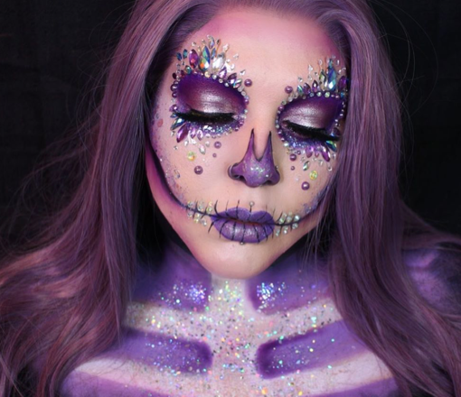
Vanity Venom
Name: Emily Clayton
Background: I am a creative media makeup artist who's known for my avant-garde beauty looks and punk makeup style.
How long have you been in Dubai? 2 years
Professional Background: I have worked for a huge range of brands, publications and events including London Fashion Week, Jean Paul Gaultier, NYX Cosmetics, MAC Cosmetics, Ru Pauls Drag Con, and Cirque Le Soir London and Dubai.

My editorial work has been featured in Elle Middle East, Elle Arab World, Makeup Artist Magazine and more.

Any other fun facts about you: Since 2016 I’ve demonstrated my work at IMATS London and I was an official Educator for the London convention in 2017 and 2018. In January 2019 I showcased my work at the Los Angeles and New York Conventions. I was also a judge for The Battle Of The Brushes and both LA and New York.

Preferred Style: Creative or Glam
Availability: I’m freelance so my calendar is very varied.
Masterclasses offered? I work as a makeup teacher at AOFM, so I’m more than comfortable. teaching large groups.
Rough price guide: Glam makeup starts from 500, Creative makeup from 600-700 but most of my quotes are custom to the kind of work required.
Contact details:
IG: @vanityvenom
www.vanityvenom.com
Emily_eclayton@hotmail.co.uk

Want to be added to this list? Please email me at sherrie@howtohen.com

